

Penitration testing

& sEcuring cloud

network

**R0HIT GUPTA**

**CLOUD CREATION**



Amazon Web Services (AWS) is a subsidiary of Amazon that provides on-demand cloud computing platforms to individuals, companies and governments, on a metered pay-as-you-go basis. In aggregate, these cloud computing web services provide a set of primitive, abstract technical infrastructure and distributed computing building blocks and tools. One of these services is Amazon Elastic Compute Cloud, which allows users to have at their disposal a virtual cluster of computers, available all the time, through the Internet. AWS’s version of virtual computers emulate most of the attributes of a real computer including hardware (CPU(s) & GPU(s) for processing, local/RAM memory, hard-disk/SSD storage); a choice of operating systems; networking; and pre-loaded application software such as web servers, databases, CRM, etc.

**EC2**

An EC2 instance is a virtual server in Amazon’s Elastic Compute Cloud (EC2) for running applications on the Amazon Web Services (AWS) infrastructure. AWS is a comprehensive, evolving cloud computing platform; EC2 is a service that allows business subscribers to run application programs in the computing environment. The EC2 can serve as a practically unlimited set of virtual machines.

**CREATING INSTANCE**

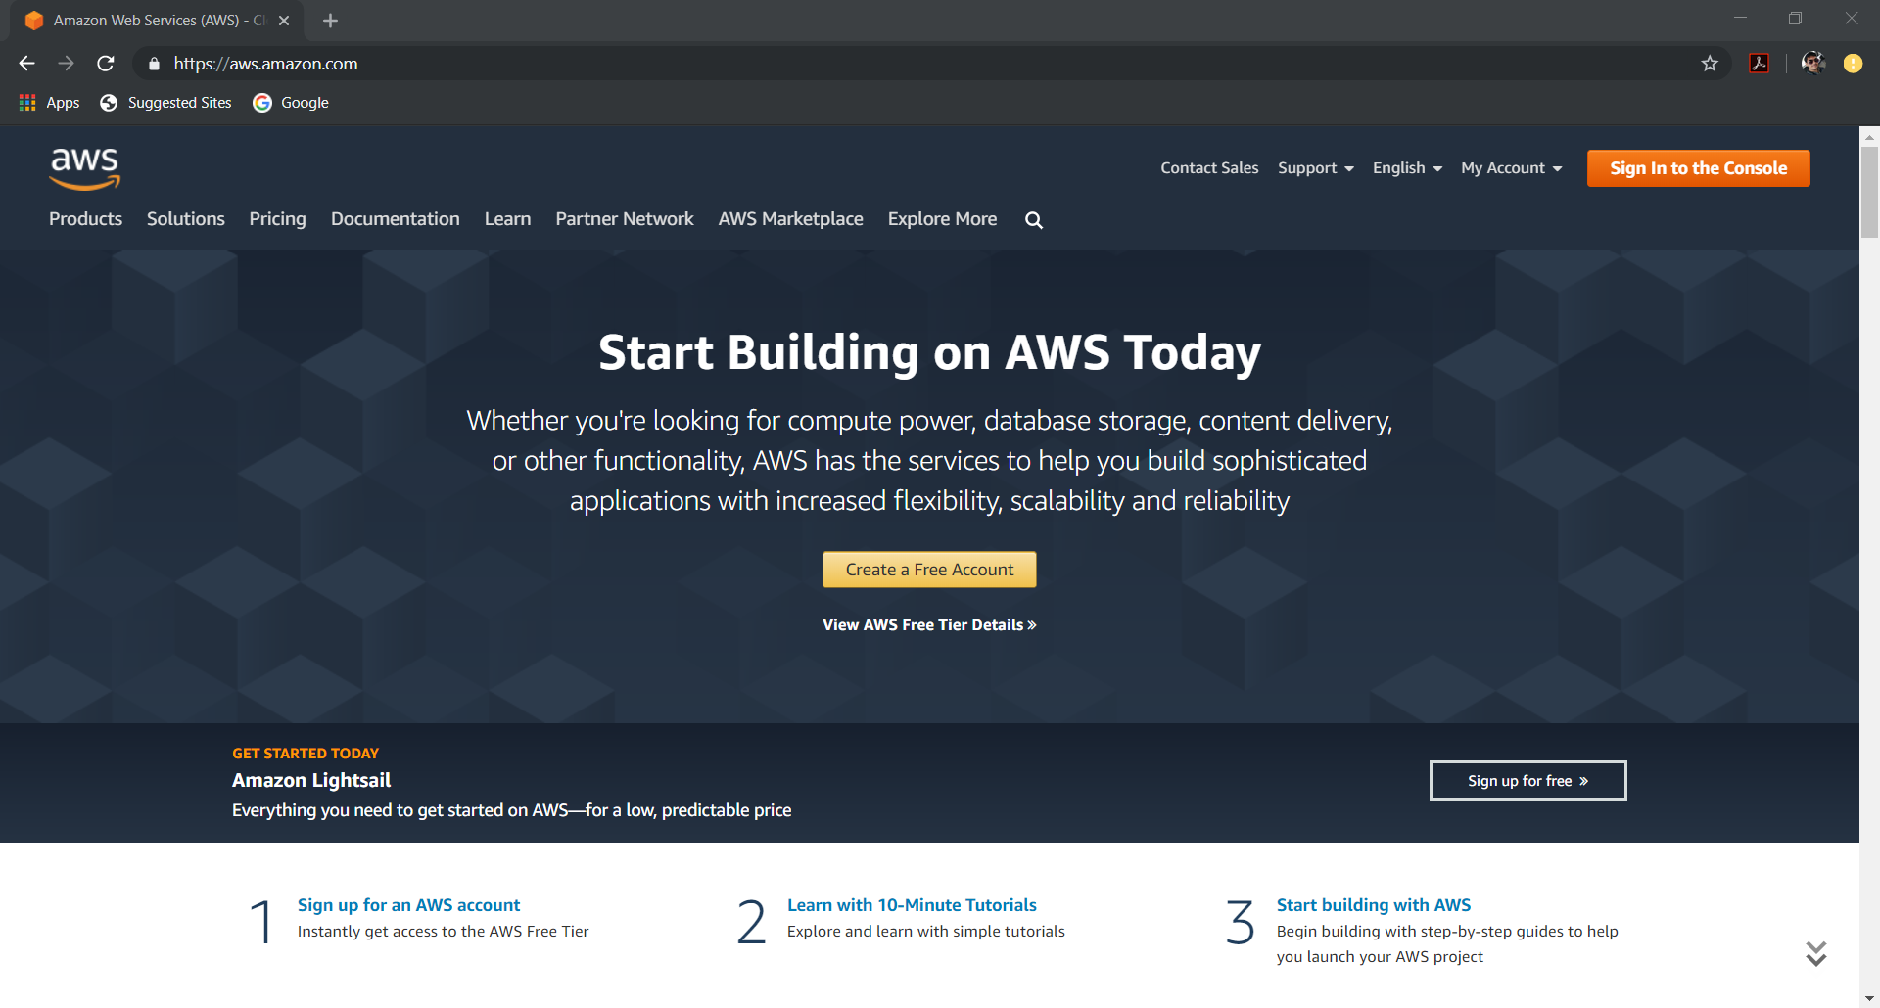

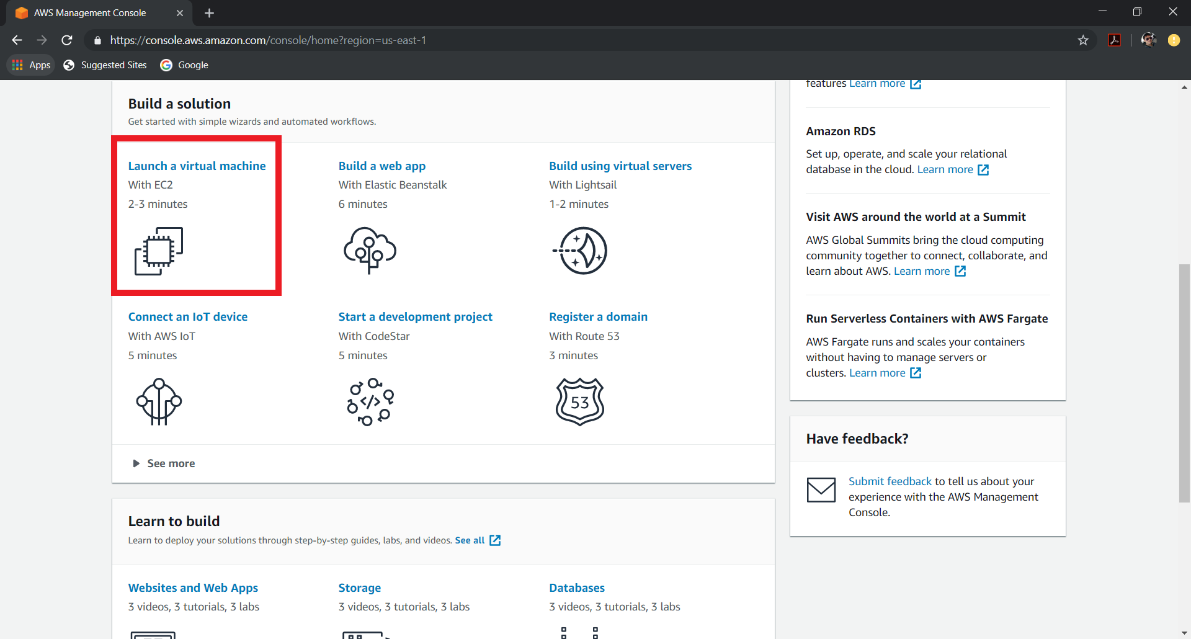

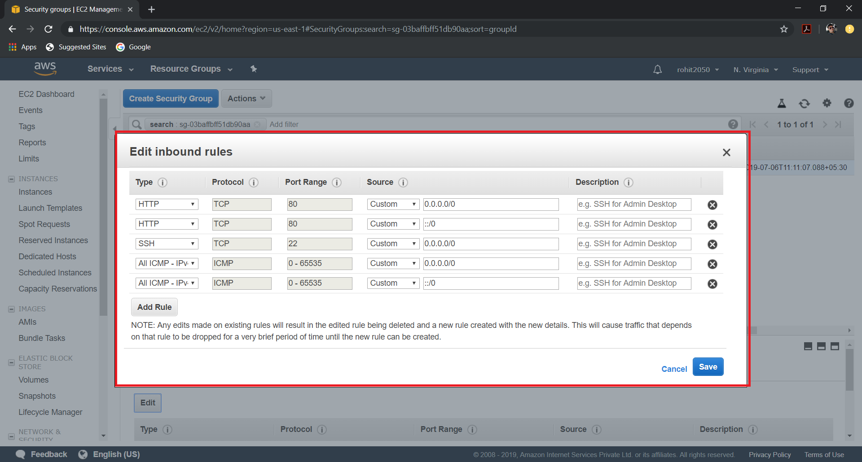

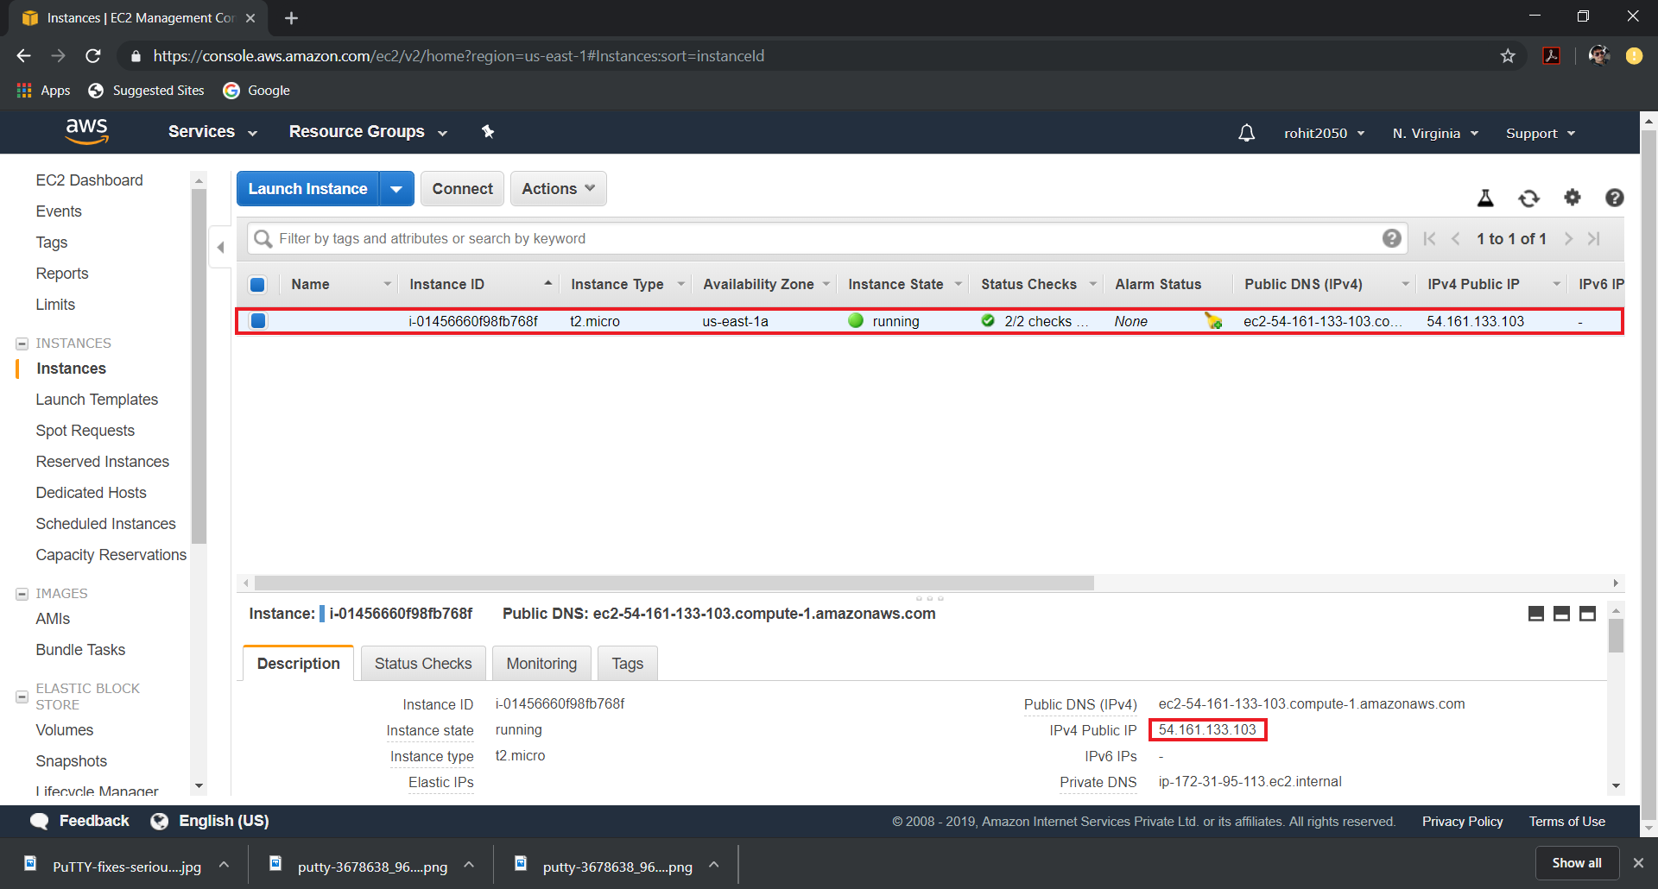

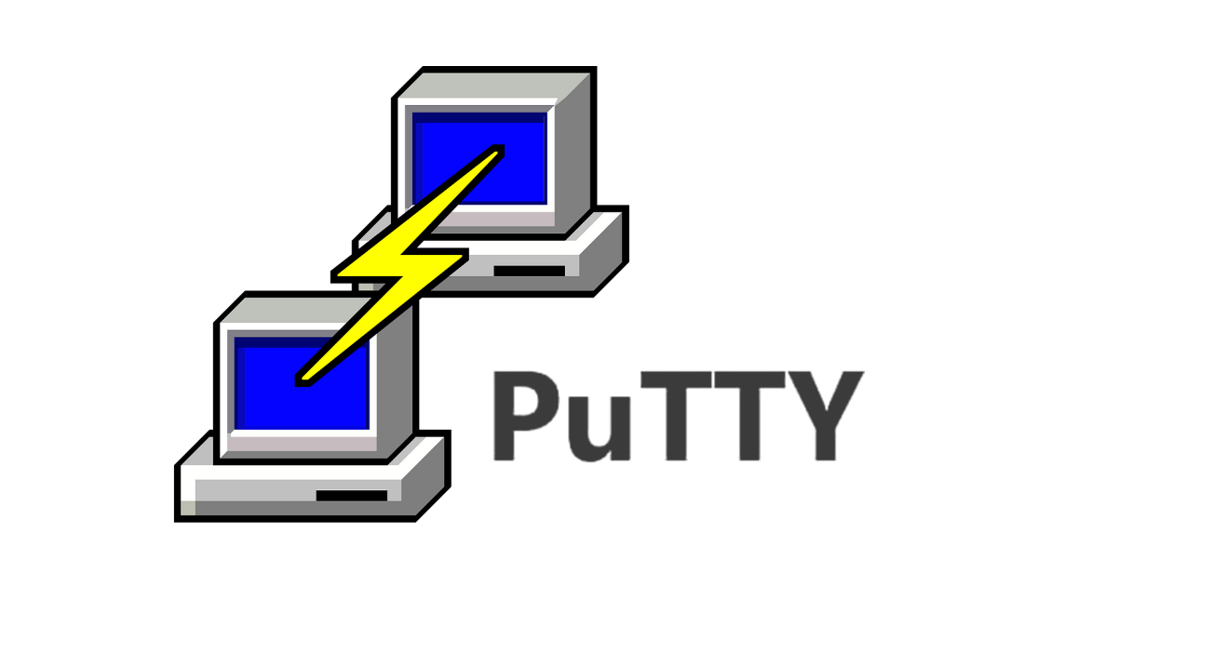

It is a free and open-source terminal emulator, serial console and network file transfer application. It supports several network protocols, including SCP, SSH, Telnet, rlogin, and raw socket connection. It can also connect to a serial port. The name "PuTTY" has no official meaning.

PuTTY was originally written for Microsoft Windows, but it has been ported to various other operating systems. Official ports are available for some Unix-like platforms, with work-in-progress ports to Classic Mac OS and macOS, and unofficial ports have been contributed to platforms such as Symbian, Windows Mobile and Windows Phone.

**PUTTYGEN**

PuTTYgen originates from PuTTY and is also part of the PuTTY installation package. It does not matter if you use PuTTYgen from WinSCP or the PuTTY installation package, they are identical.

When you run PuTTYgen you will see a window where you have two choices: Generate, to generate a new public/private key pair, or Load to load in an existing private key.

**GENERATING THE KEY**

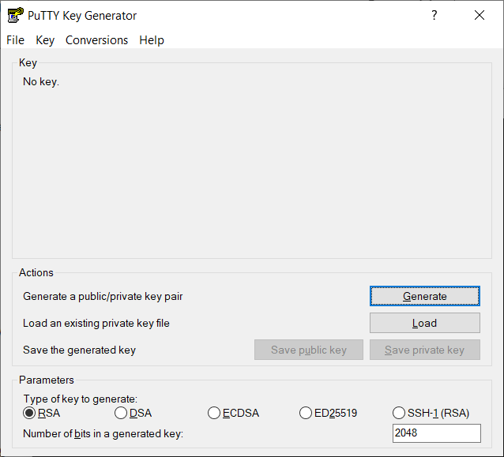

**SETTING IT UP**

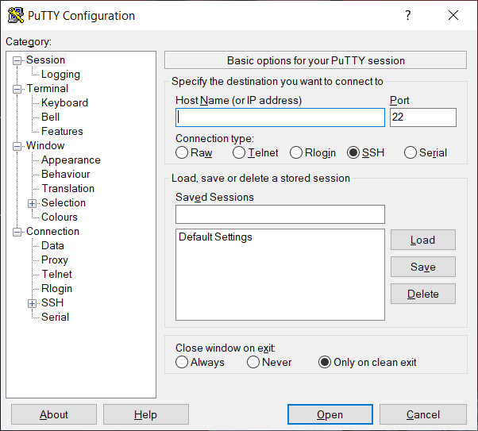

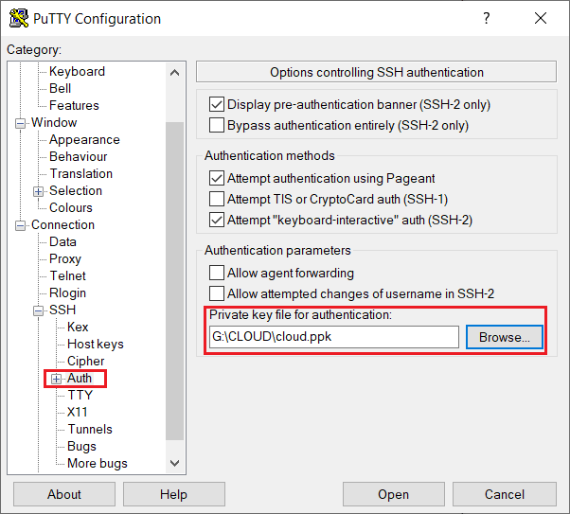

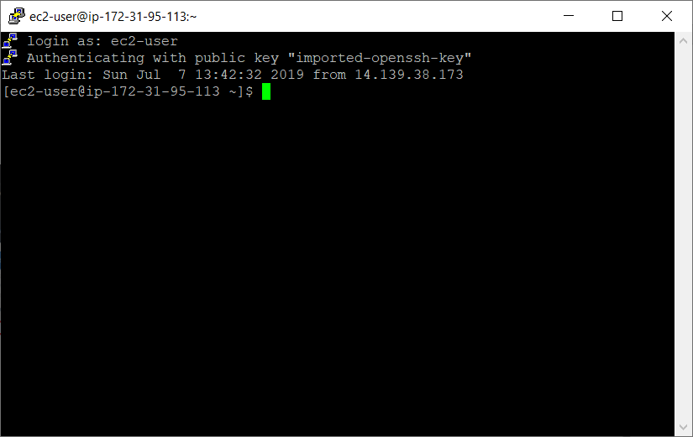

**SETTING UP THE LAMP SERVER**

>>Installing httpd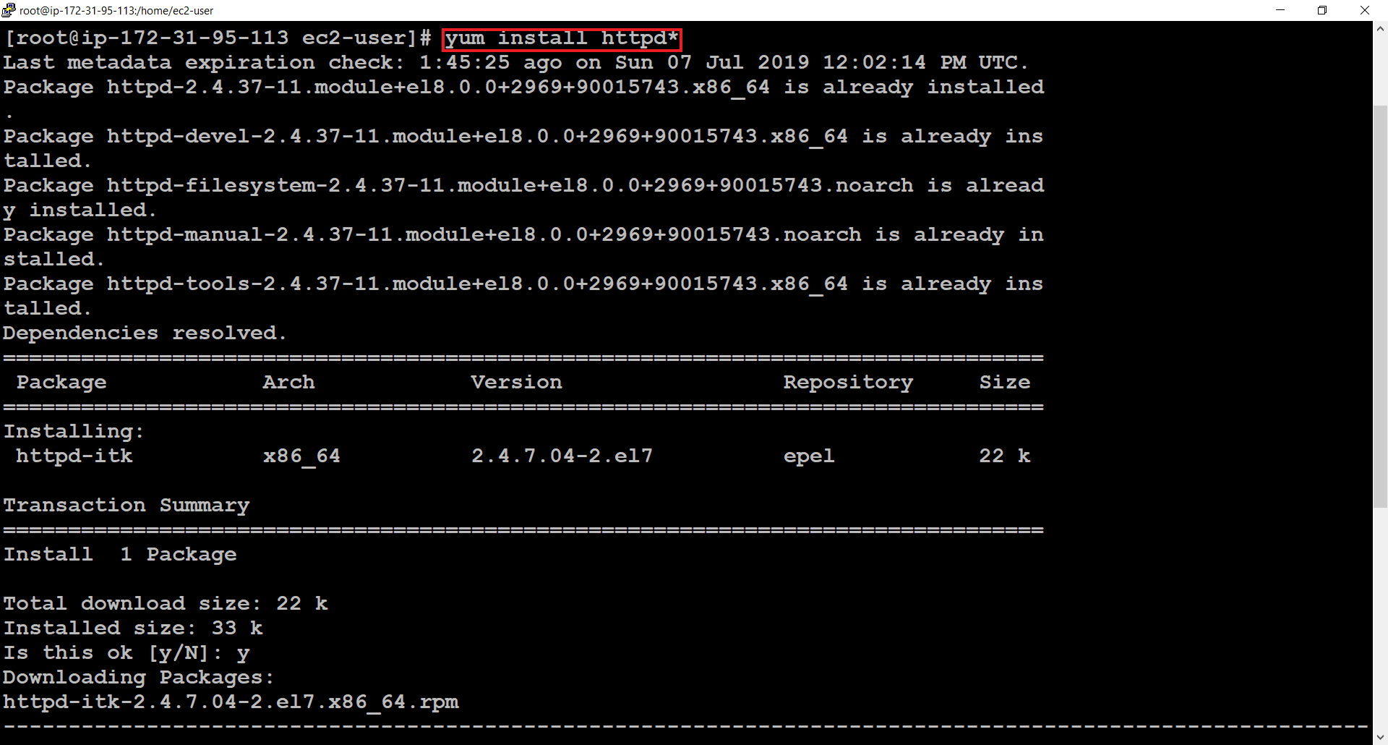

>>Installing mariadb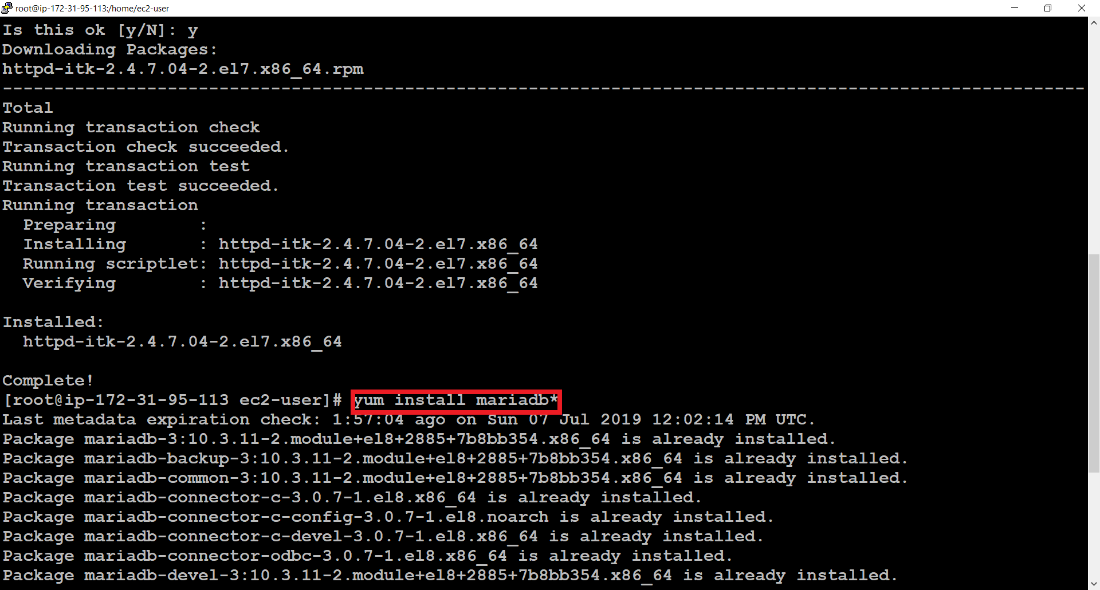

>>Installing PHP

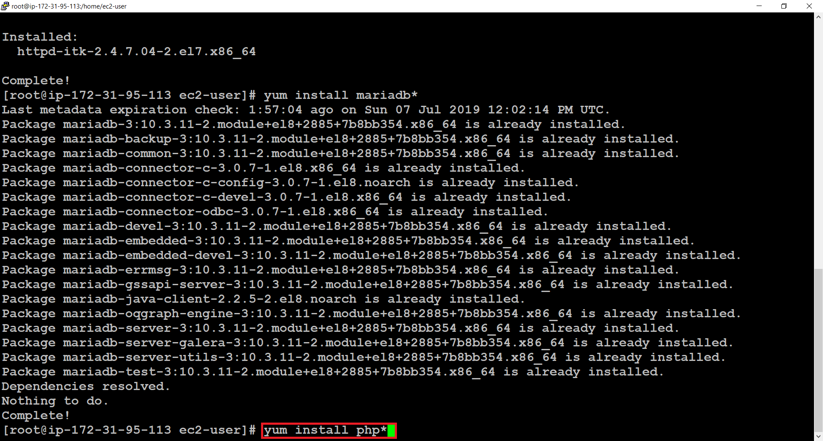

>>Starting Services

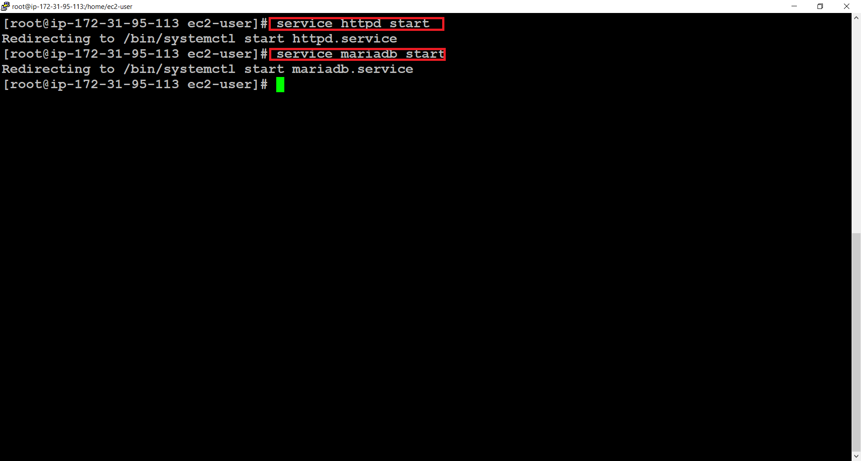

>>Permanently starting the services

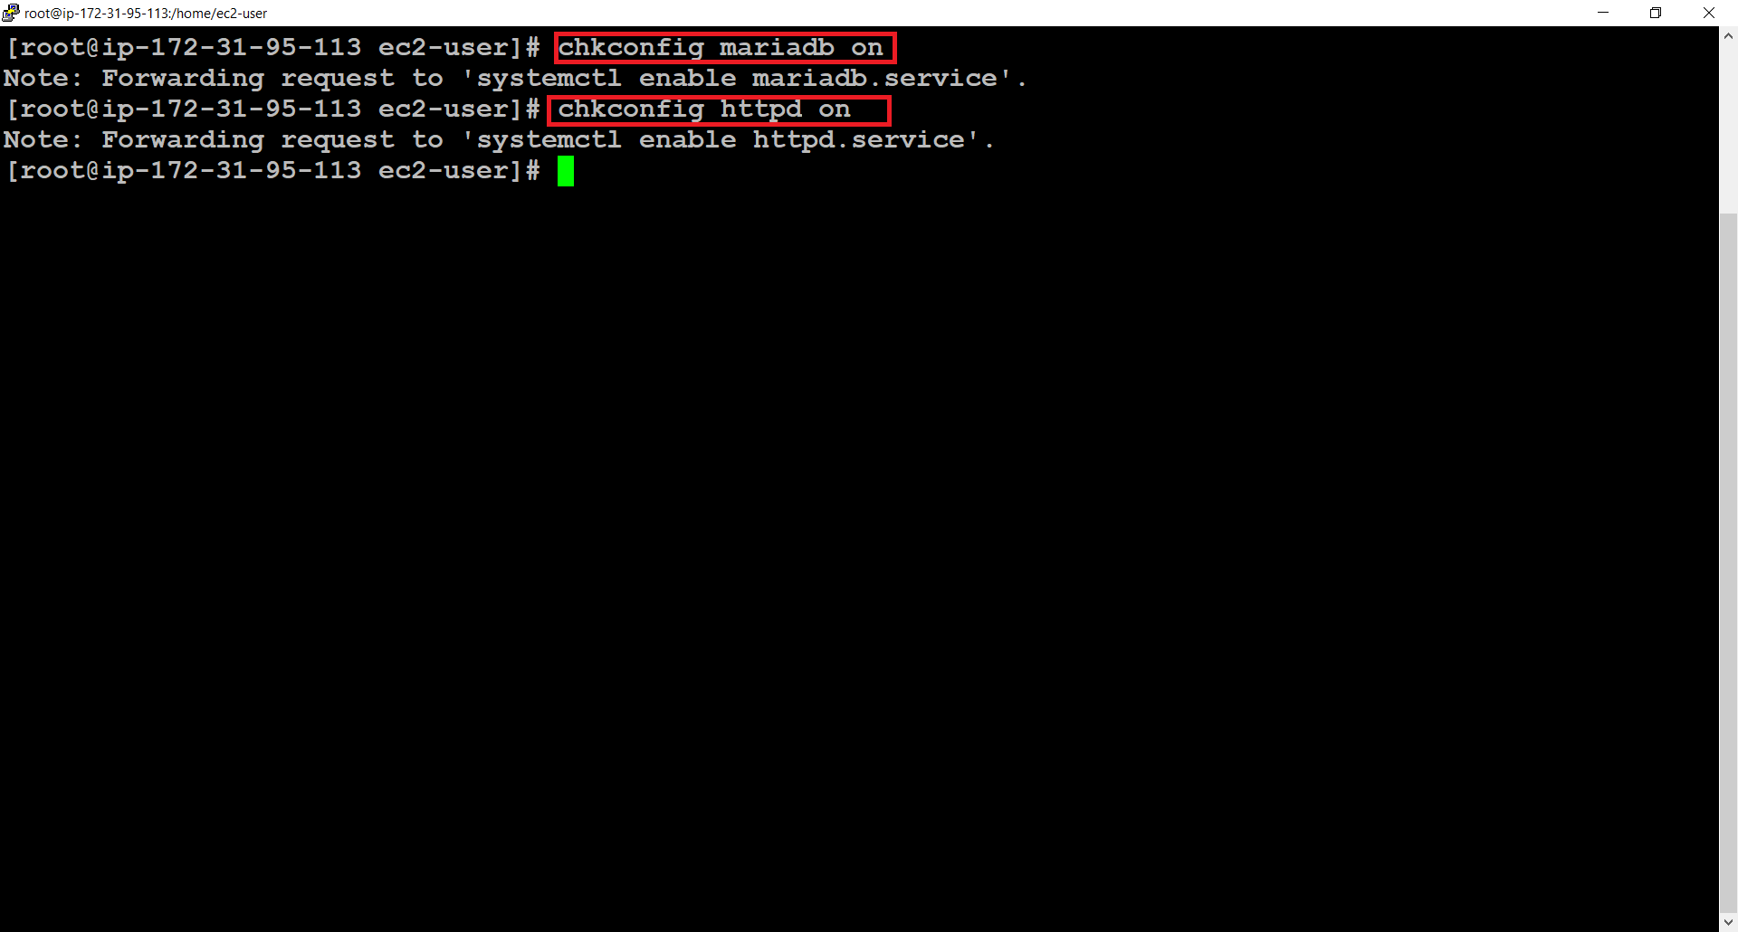

>>Disabling selinux

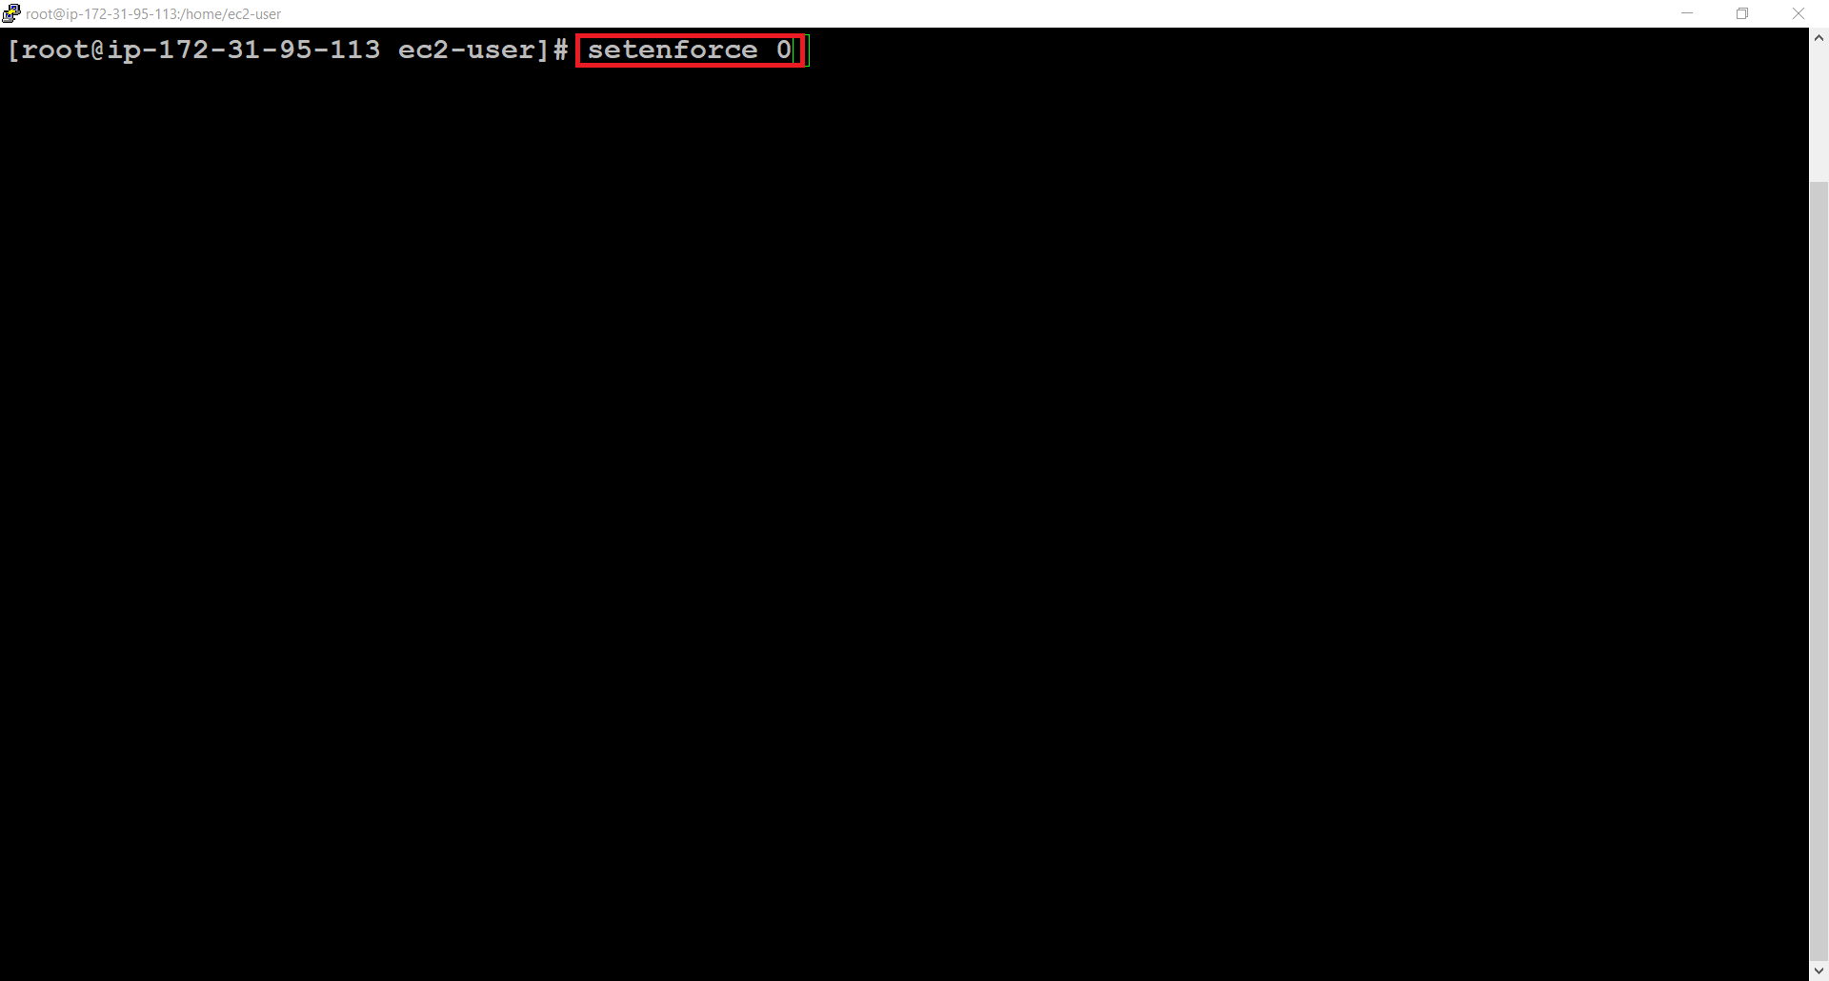

**CREATING DATABASE**

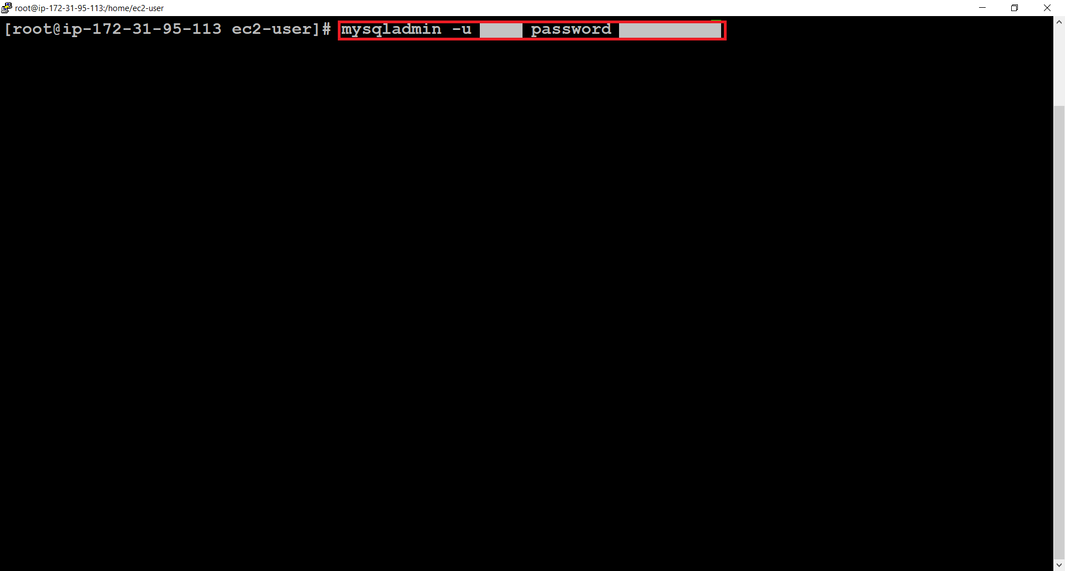

>>Login as root

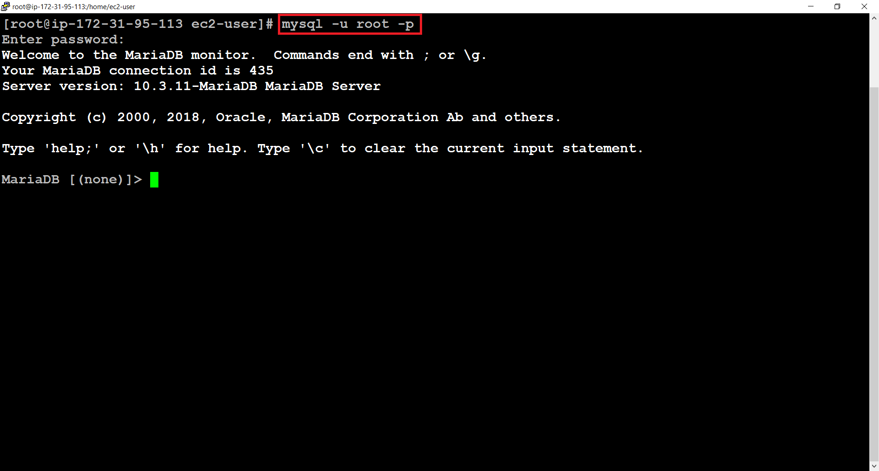

>>Creating User

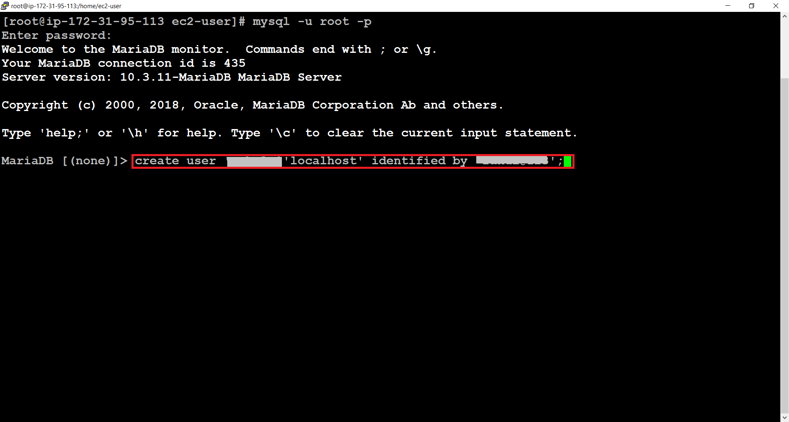

>>Creating owncloud database

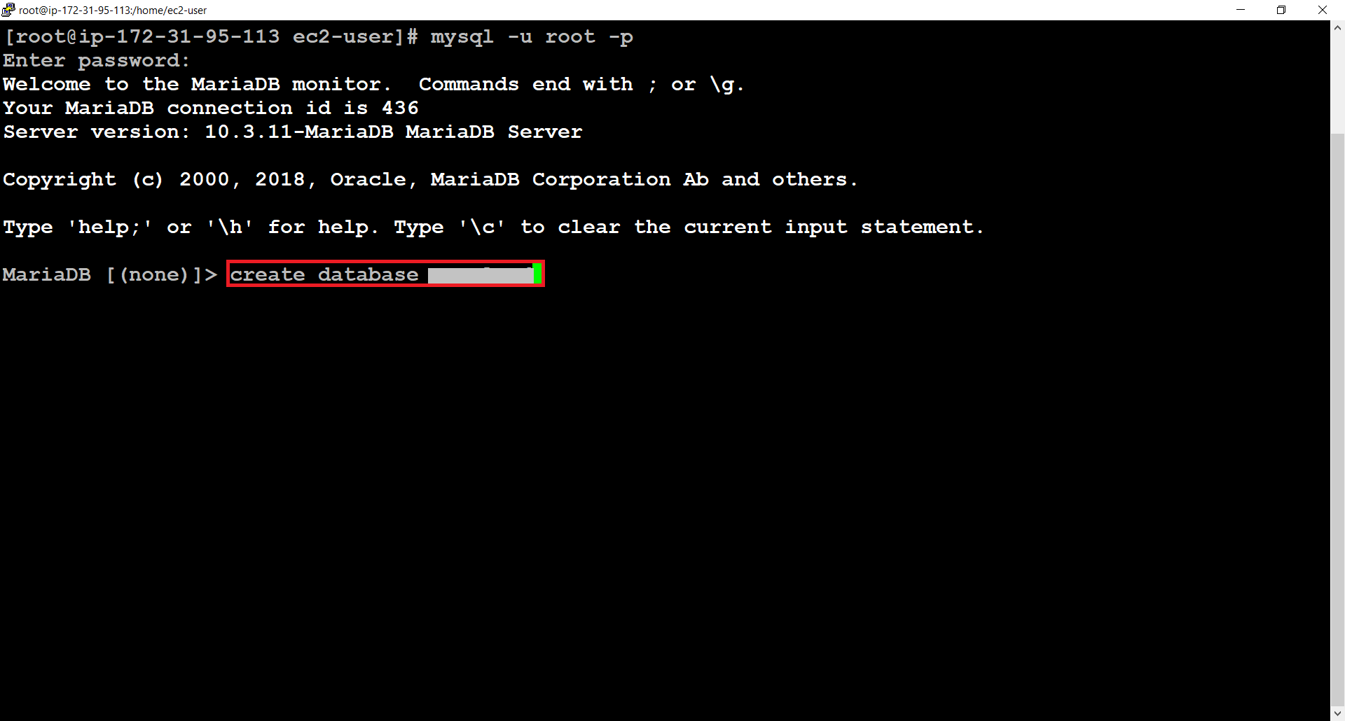

>>Giving privileges to the user

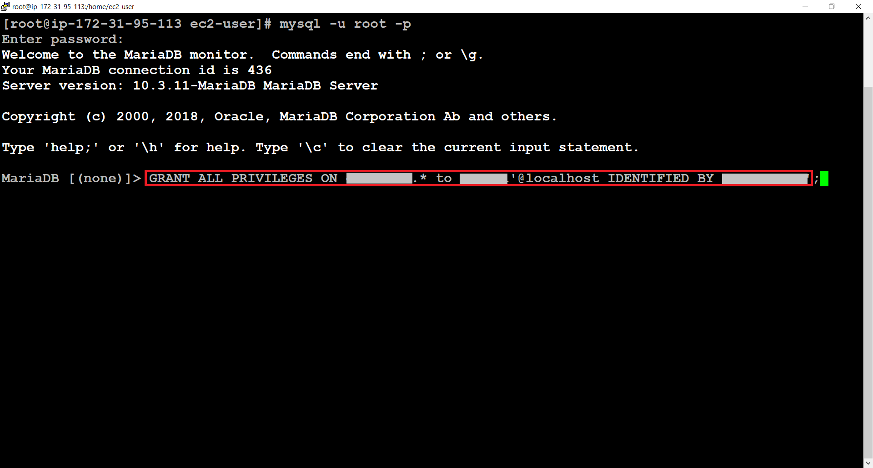

**INSTALLING OWNCLOUD**



OwnCloud is a suite of client–server software for creating and using file hosting services. ownCloud functionally has similarities to the widely used Dropbox. The primary functional difference between ownCloud and Dropbox is that ownCloud does not offer data centre capacity to host stored files. The Server Edition of ownCloud is free and open-source, thereby allowing anyone to install and operate it without charge on their own private server.

>> adding repositry

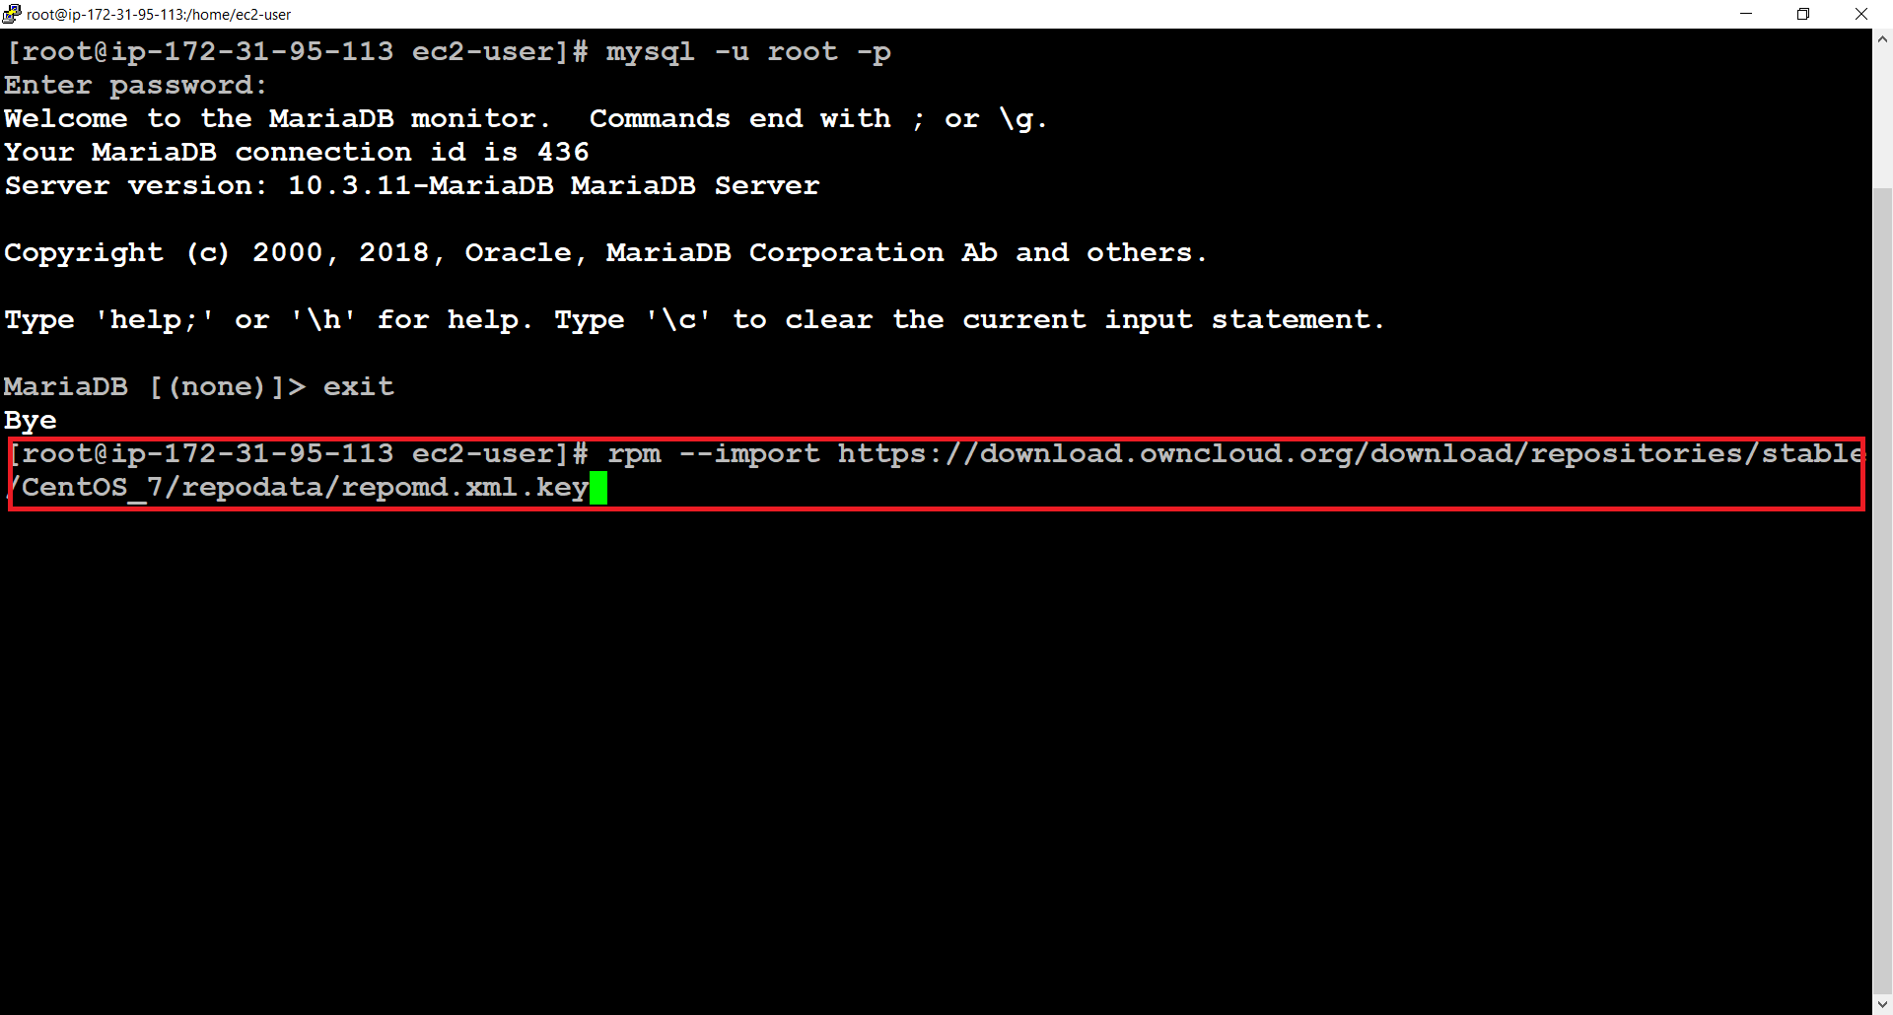

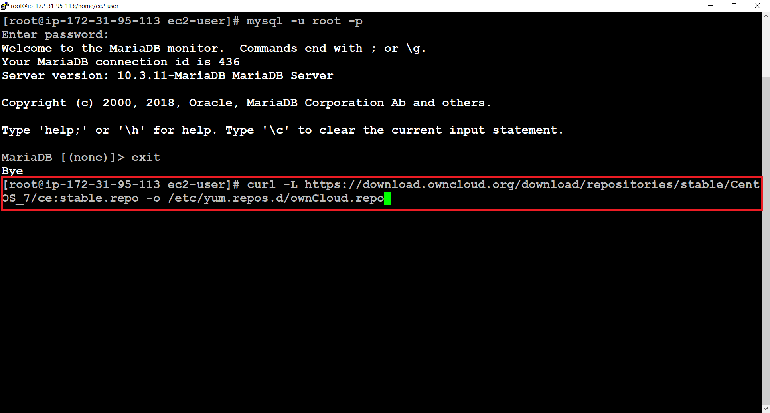

>>Install OwnCloud

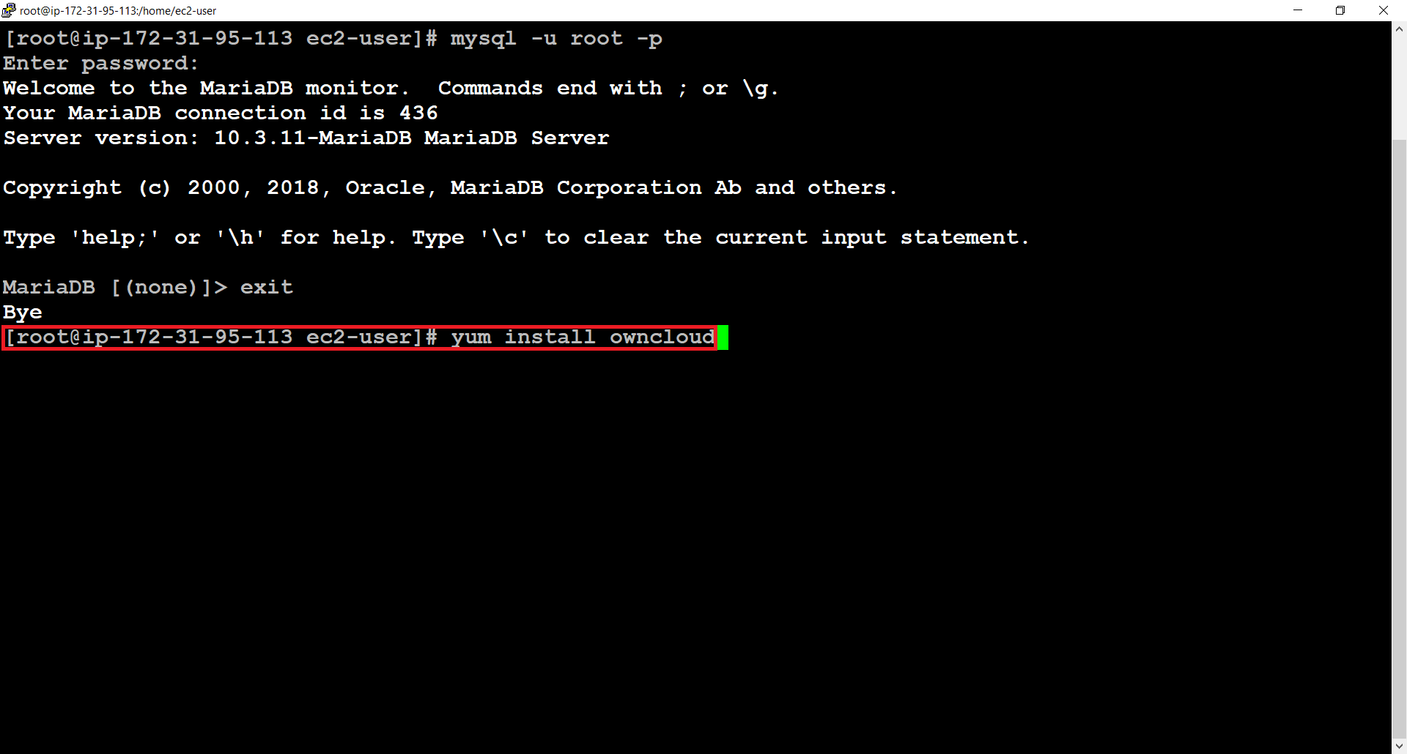

>>Restarting services

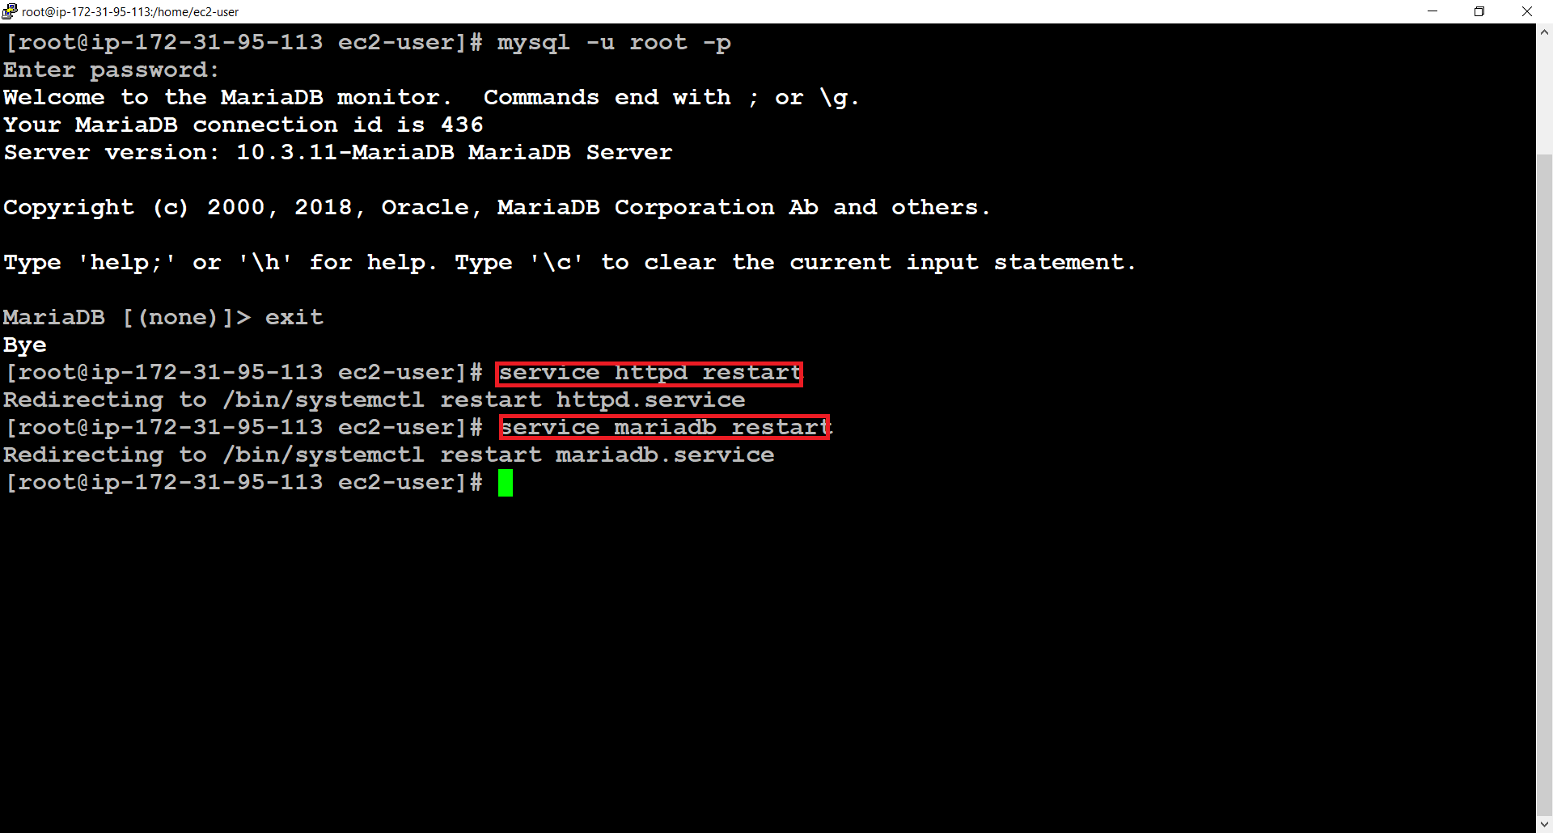

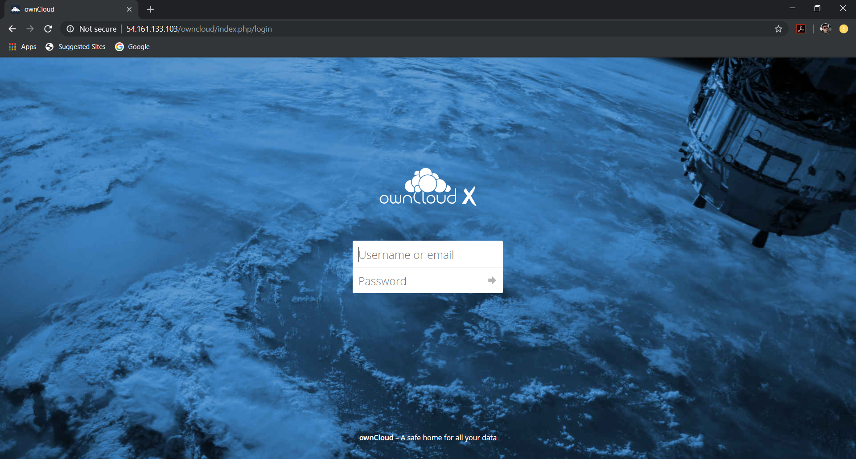

**CREATING USERS AND GROUPS**

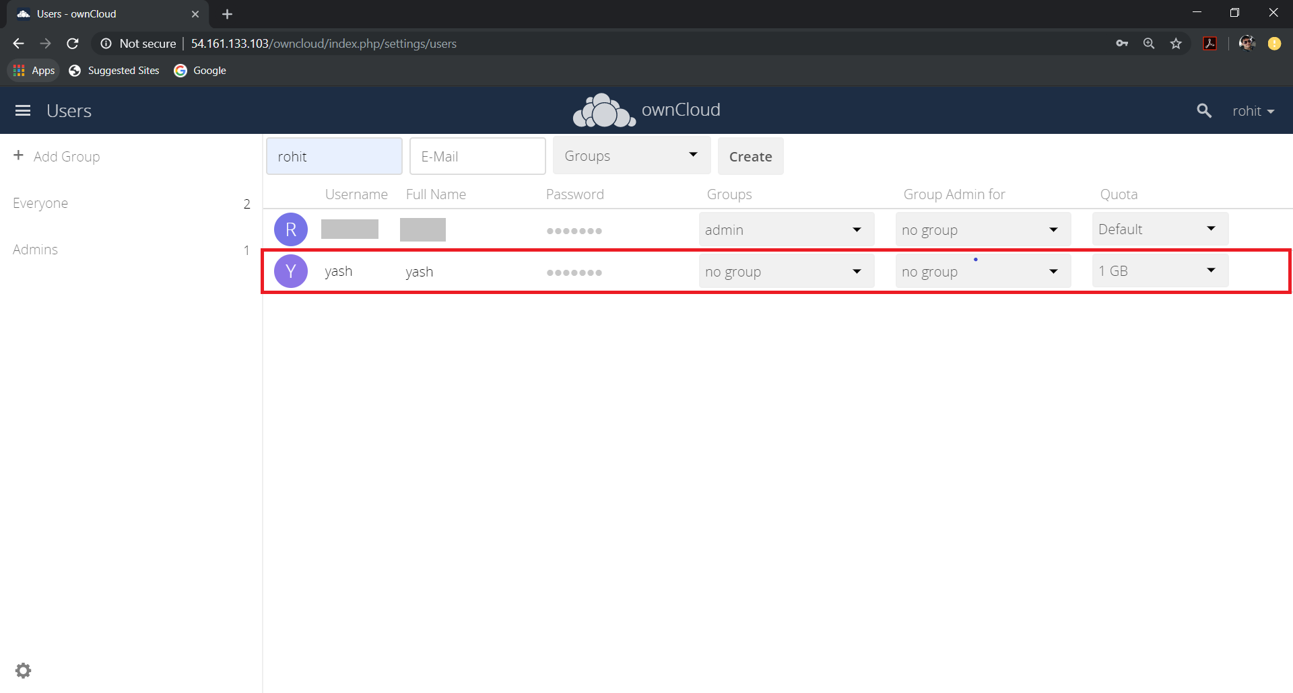

**LIMITING THE DISK USAGE TO 2GB/USER**

